Name _________________________________________ AP Biology Reading Guide Fred and Theresa Holtzclaw Copyright © 2010 Pearson Education, Inc.

Chapter 17: Gene Expression: From Gene to Protein

1) What is gene expression?

17.1 Genes specify proteins via transcription and translation
2) Explain the “one gene-one polypeptide hypothesis”

3) Define each of these processes that are essential to the formation of a protein:

Transcription:

Translation:

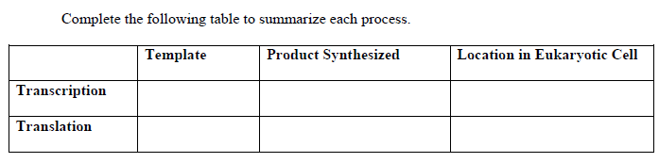
4)

5) How does the protein building process differ in prokaryotes and eukaryotes?

6) Here is a short DNA template. Below it, assemble the complementary mRNA strand. Label the codons.
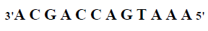

7) What is the start codon? ____________________________________________________

8) The enzyme which transcribes the DNA is ________________________________________

The strand of DNA that is transcribed is called ____________________________________

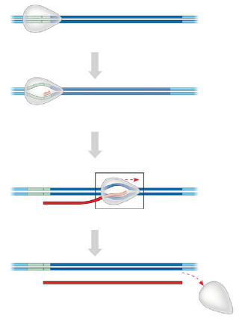
17.2 Transcription is the DNA-directed synthesis of RNA: a closer look
9) Figure 17.7 in your text will require a bit of study. Use it to label the following elements on the figure below: promoter, RNA polymerase, transcription unit, DNA template, nontemplate DNA, and RNA transcript. Then, below name the three stages of transcription and briefly describe each stage.

10) What is the TATA box? How do you think it got this name?

17.3 Eukaryotic cells modify RNA after transcription
11) RNA processing occurs only in eukaryotic cells. The primary transcript is altered at both ends, and sections in the middle are removed.
a. What happens at the 5' end?

b. What happens at the 3' end?

12) What is the advantage of the 5’ cap and poly A tail?

13) Distinguish between exons and introns.
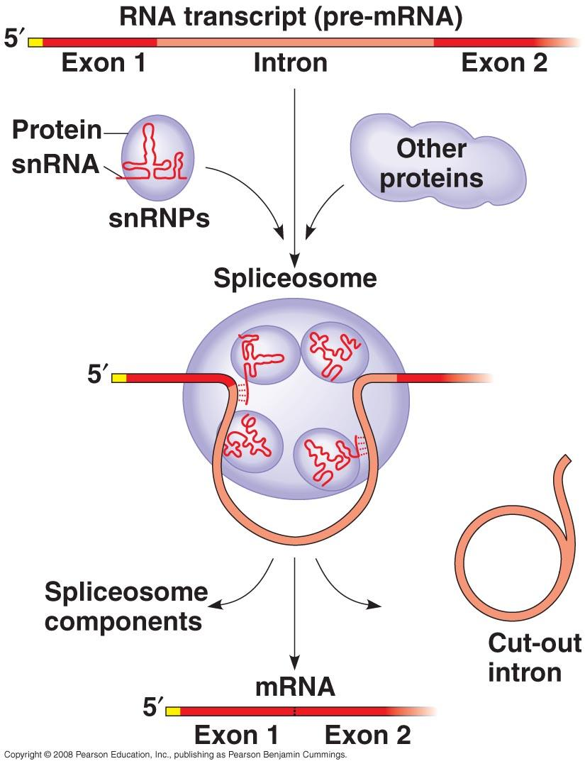

14) How do spliceosomes work? Study figure 17.12 carefully to explain how spliceosomes modify pre-mRNA.

15) What is a ribozyme? What commonly held idea was rendered obsolete by the discovery of ribozymes? When a protein and an snRNA are put together, what are they called?

17.4 Translation is the RNA-directed synthesis of a polypeptide: a closer look
16) Briefly describe the function of each type of RNA.
a. rRNA

b. mRNA

c. tRNA

17) Identify the roles of the players of the translation process.
a. Transfer RNA

b. anticodon

c. Ribosomes

18) On this figure, label the large subunit, small subunit, A, P, and E sites, mRNA binding site. To the right of the figure, explain the functions of the A, P, and E sites.

19) Summarize the events of initiation. Include these components: small ribosomal subunit, large ribosomal subunit, mRNA, initiator codon, tRNA, Met, initiation complex, P site, and GTP. The figure below may help you.
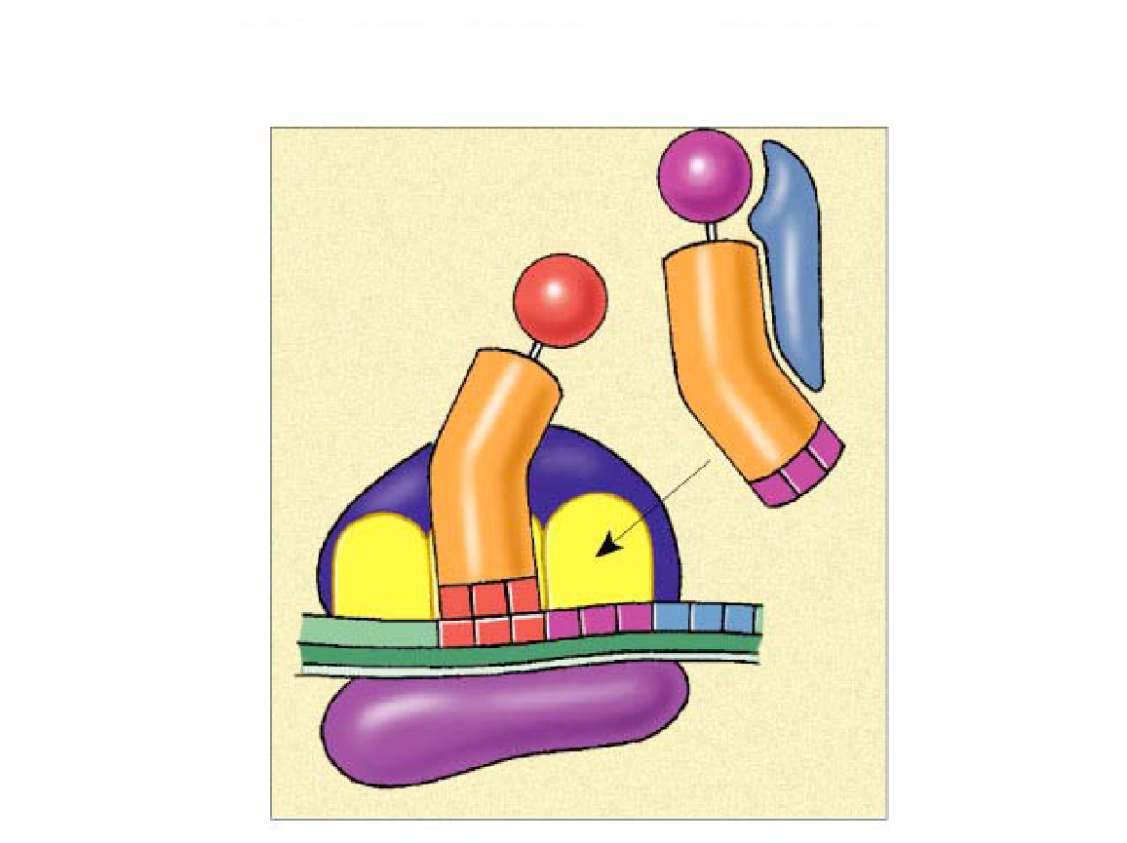

20) Now, summarize the events of elongation. Include these components: mRNA, A site, tRNA, codon, anticodon, P site, and E site. The figure below may help you.
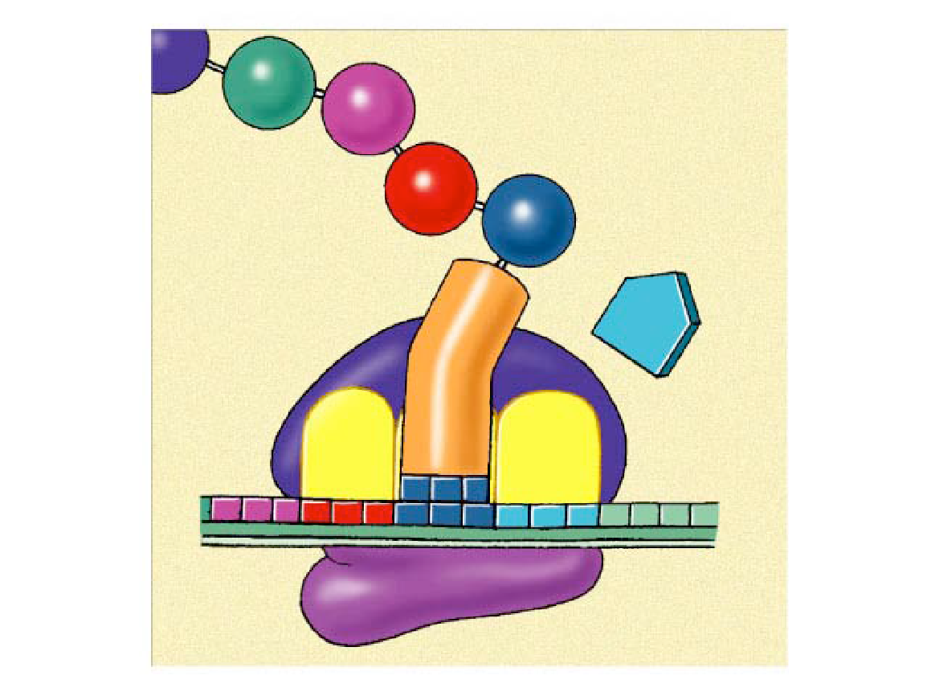

21) Explain termination (using figure 14.20) and what a signal peptide is.

17.5 Mutations of one or a few nucleotides can affect protein structure and function
22) Define a mutation in terms of molecular genetics. What is a point mutation?

23) Define mutations that are:
a. frameshift

b. Missense

c. Nonsense

d. Insertion or deletion

e. Silent mutation

f. mutagens

24) Use figure 17.26 to trace the flow of chemical information from the gene to the protein product. Make sure you can explain what is going on and all the steps of protein synthesis based on this picture.
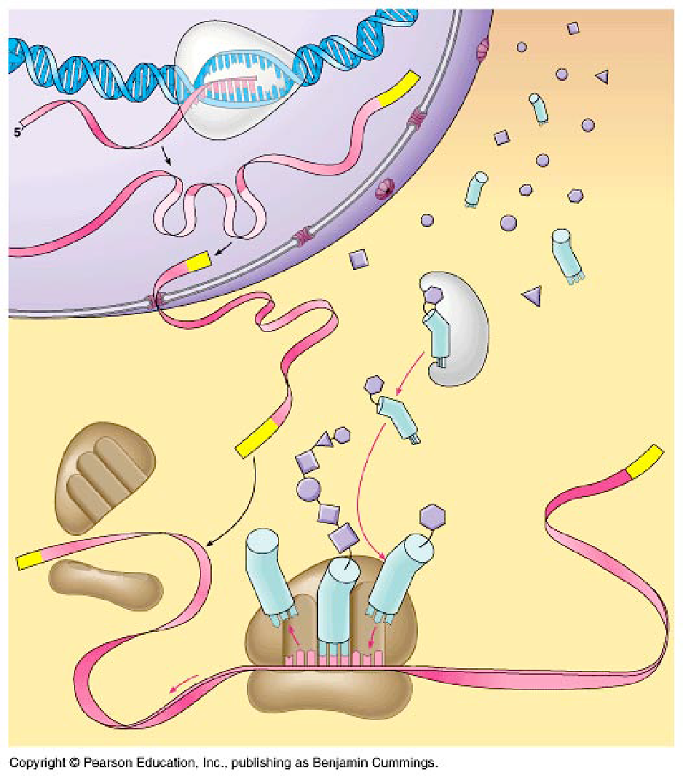

Name _________________________________________ AP Biology Reading Guide Fred and Theresa Holtzclaw Copyright © 2010 Pearson Education, Inc.

Chapter 18: Regulation of Gene Expression

18.1 Bacteria often respond to environmental change by regulating transcription
1) What is a gene’s promoter? What role does it serve in regulating transcription?

2) Prokaryotes use a regulatory system called an operon. Explain what an operon is:

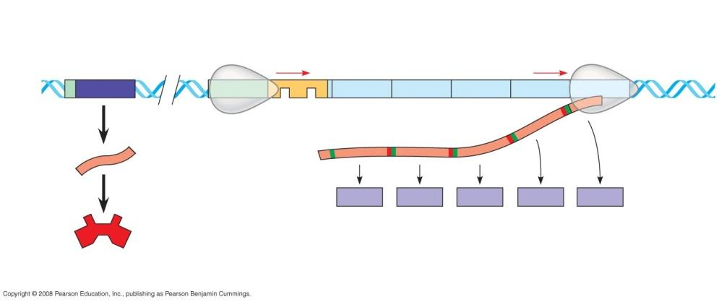

3) Label figure 18.3, and identify the function of the following components:
promoter:

operator:

repressor:

(Also label: RNA polymerase, operon, regulatory gene, start and stop codons)

4) How does a repressor protein work?

5) What are regulatory genes?

6) Distinguish between inducible and repressible operons, and describe one example of each type.

18.2 Eukaryotic gene expression is regulated at many stages
7) Even though all cells of an organism have the same genes, there is differential gene expression. What does this mean?

8) What occurs in histone acetylation? How does it affect gene expression?

9) What is DNA methylation? What role may it play in gene expression?

10) Explain what is meant by epigenetic inheritance, and give an example of epigenetic changes discussed in the text or in class.

11) Use figure 18.10 below to explain how enhancers and activators interact with transcription factors to affect gene expression. Label the following elements: TATA box, promoter, gene, enhancer, activators, transcription factors, transcription initiation complex, RNA polymerase II, and DNA. Then place your explanation to the right of the figure.
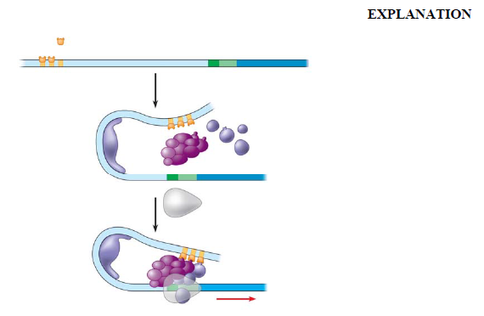

12) Operons have not been found in eukaryotic cells, and the genes coding for the enzymes of a particular metabolic pathway are often scattered over different chromosomes. What is a plausible mechanism for the coordination of gene expression?

18.3 Noncoding RNAs play multiple roles in controlling gene expression
13) Post-transcriptional control includes regulation of mRNA degradation. Explain how this affects translation.

Name _________________________________________ AP Biology Reading Guide Fred and Theresa Holtzclaw Copyright © 2010 Pearson Education, Inc.

Chapter 18 & 20: Development, Stem Cells, and Cancer

18.4 A program of differential gene expression leads to the different cell types in a multicellular organism
1) Explain what occurs in cell differentiation and morphogenesis.

2) Differential gene expression results from different activators in different cells. How do different sets of activators come to be present in two cells? Explain how each of these occurs:

a. distribution of cytoplasmic determinants

b. different inductive signals

3) a. What is meant by determination? Explain what this means within an embryonic cell.

b. What is apoptosis and how does it play a role in development?

4) What process ensures that all the tissues and organs of an organism are in their characteristic places? Where do the molecular cues that control this process arise?

5) What is controlled by homeotic genes?

18.5 Cancer results from genetic changes that affect cell cycle control

6) What mechanism is involved in the beginning of tumor growth? Discuss oncogenes and proto- oncogenes and how they are converted. What mechanism is involved in the beginning of tumor growth?

7) Tumor-suppressor genes help prevent uncontrolled cell growth. One that is found mutated (and therefore nonfunctional) in more than 50% of human cancer is p53. So important is the p53 gene that it is sometimes called the “guardian angel of the genome.” Describe the double whammy that results from mutation of p53.

11) Explain the multistep model of cancer development and compare it to embryonic development.

20.3 Cloned organisms and stem cells are useful for basic research and other applications
6) How is nuclear transplantation performed in animals?

7) What are stem cells? What is the major difference between embryonic stem cells (ES) and adult stem cells?

8) How might induced pluripotent stem cells (iPS) resolve the debate about using stem cells for medical treatments?

Name _________________________________________ AP Biology Reading Guide Fred and Theresa Holtzclaw Copyright © 2010 Pearson Education, Inc.
Chapter 19 & 27: Viruses

Overview
Experimental work with viruses has provided important evidence that genes are made of nucleic acids. Viruses were also important in working out the molecular mechanisms of DNA replication, transcription, and translation. Viruses have been important in the development of techniques of manipulating and transferring genes. As you learn about viruses in this chapter, you will build on the foundation necessary for an understanding of the molecular techniques of biotechnology.

19.1 A virus consists of a nucleic acid surrounded by a protein coat
1) List several characteristics of viruses.

2) What is a capsid?

3) What is the role of an envelope in animal viruses?

19.2 Viruses replicate only in host cells
4) What is meant by host range? Distinguish between a virus with a broad host range and one with an extremely limited host range, and give an example of each.

5) What are bacteriophages? Distinguish between lytic and lysogenic phages.

6) What portion of a phage enters the host cell? How does it do this?

7) Label the following elements of figure 19.6 below: phage, lysogenic cycle, lytic cycle, prophage, phage DNA, bacterial chromosome, and self assembly.
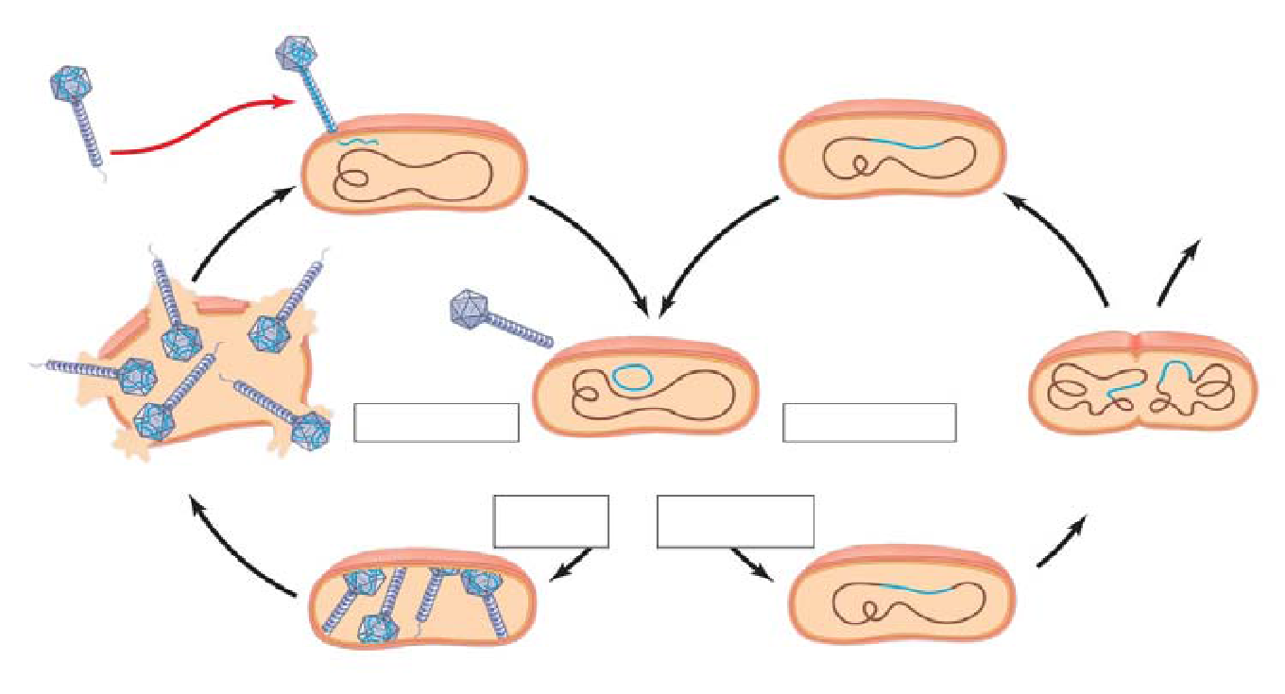

8) Compare the lytic and lysogenic cycles.

9) What is a retrovirus? How do retroviruses, such as HIV, replicate their genome?

19.3 Viruses and prions are formidable pathogens in animals and plants
10) Prions strike fear into carnivores everywhere. What are they? How are they transmitted? What do they do?

Note: 27.2 Rapid reproduction, mutation, and genetic recombination in prokaryotes p.561
11) Describe transduction.

12) Explain why viruses may mutate so quickly.

Name ____________________________________________ Fred and Theresa Holtzclaw
AP Biology
Plant Form and Function (Chapters 36-39)

36.2 Different mechanisms transport substances over short or long distances
1) Define these terms:
flaccid

turgid

plasmolysis

Concept 36.5 Transpiration drives the transport of water and minerals from roots to shoots via the xylem
3) Explain the cohesion-tension hypothesis.

Concept 36.4 The rate of transpiration is regulated by stomata
4) Leaves generally have large surface areas and high surface-to-volume ratios. Give an advantage and disadvantage of these traits.
advantage

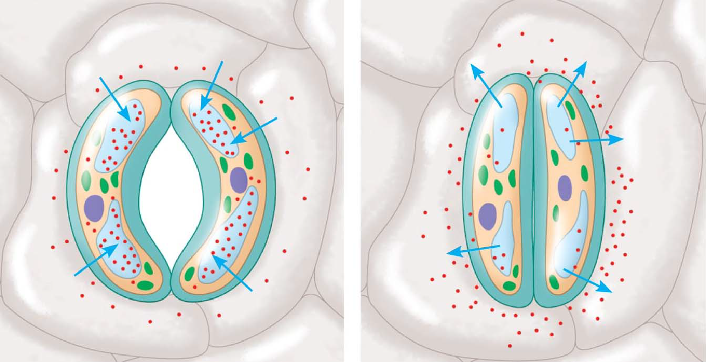
disadvantage

5) On the sketches, label the guard cell, stomata, K+, and H2O. Explain why the stoma opens when K+ accumulates in the guard cells.

6) Three types of stimuli can cause guard cells to open. Name and explain how each one works.
Stimulus for Stomatal Opening and Closing | Explanation

Concept 39.2 Plant hormones help coordinate growth, development, and responses to stimuli
7) Both plants and animals have hormones. The definition of a hormone has three parts. What are they, and how do they fit into the signal transduction pathway model?

8) What is a tropism?

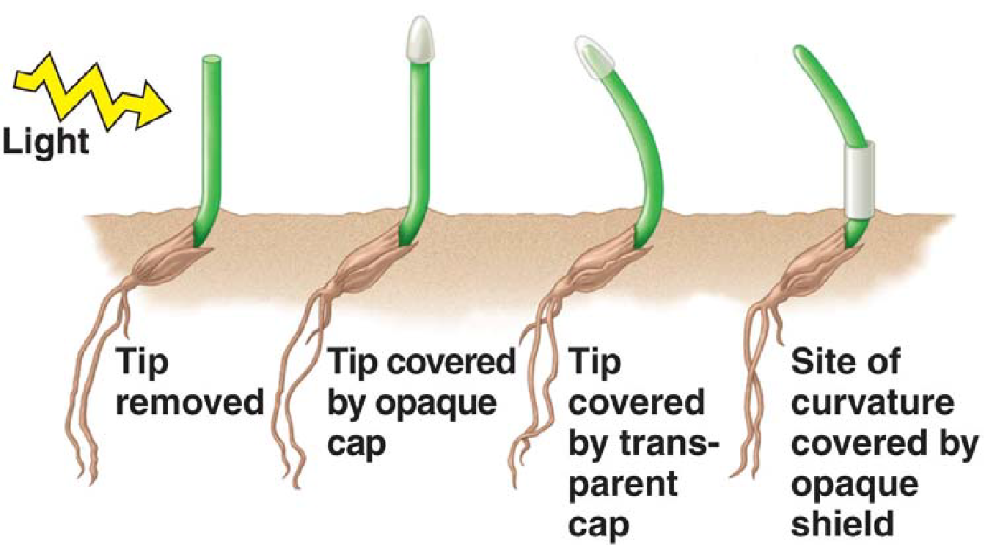
9) Figure 31.2 describes early experiments on phototropism conducted by Charles and Francis Darwin. What can be concluded from these experiments?

10) In jest, we tell our students that when in doubt about which plant hormone causes which plant response, just answer auxin. Auxin has so many functions, this answer often works. List and describe two functions of auxin.
Auxin Functions | Description

39.3 Responses to light are critical for plant success
11) What color light is absorbed by phytochromes?

12) What are two different responses initiated by blue light?

13) What is a circadian rhythm? Give one plant example and one human example.

14) Plants detect photoperiod, and in many species it affects their time of flowering. Explain each of the following, and give an example of a plant that is in the group.
short-day plant

long-day plant

day-neutral plant

39.4 Plants respond to a wide variety of stimuli other than light
15) What is gravitropism? How may a plant detect gravity?

16) What is thigmotropism? How is it adaptive?
Watch these videos and take notes as needed.
AP Bio Chapter 16, Development, Stem Cells and Cancer by Alison Dolan (there is also a recap in a related video AP Biology Chapter 15 Regulation of Gene Expression that goes with your Chapter 18 questions)
Bozeman Science: (some of these may only be in YouTube not the Bozeman Science site)
DNA Replication
Transcription Translation
Gene Regulation
Viruses
AP Bio Lab 3 Mitosis & Meiosis
AP Bio Lab 6 Molecular Biology

Plants
Plant Structure
Plant Nutrition and Transport
Plant Control

Crash Course Biology:
Evolutionary Development: Chicken Teeth

