Walling’s Winter Workout’s
During your time off choose at least 2 days during the week and complete the Workout Of the Day or WOD. Record your days on the tracker on the backside and have a parent/guardian sign off each day. Each exercise should take you no more than 30 minutes depending on your effort level. We have done all of the exercises included in the workout but you might not remember what they are all called. If you are not sure what an exercise is you can do a quick Google search and a video or picture demonstration will show up for each exercise provided.
Warm-Up:  - 1 min of jumping jacks  - 30 seconds of high knees  - 2 min running in place  Cool-Down: Stretch-hold each stretch for 15-20 secs.  - Seated lean back (deltoids & chest)  - Back scratcher stretch (triceps)  - Bicep extension stretch (biceps)  - Pillar stretch (core & upper body)  - Beauty queen stretch (glutes & lower back)  - Butterfly stretch (hip flexors)  - Side quad stretch (quadriceps)  - Hamstring stretch or toe touch (hamstrings)  - Figure 4 stretch (hip flexors)  - Calf stretch (calves) | Monday WOD  Mummy Monday! Pyramid WOD. In this WOD the workout will gradually increase in difficulty peaking at the top and working its way back down like a pyramid.  - 10 push-ups  - 20 sumo squats (wide leg squat)  - 30 dips  - 40 ski lunges  - 50 flutter kicks  - 60 second wall squat  - 70 jumping jacks  - 80 mountain climbers  - 70 jumping jacks  - 60 second wall squat  - 50 flutter kicks  - 40 ski lunges  - 30 dips  - 20 sumo squats (wide leg squat)  - 10 push-ups | Tuesday WOD  TABATA Tuesday! TABATA is 20 seconds of work and 10 seconds of rest for 8 cycles. You can use a timer to complete this WOD or find a TABATA music track on YouTube that will count everything for you including a 1-2 minute rest in between each round. Alternate exercise A & B each cycle for a total of 4 cycles of each exercise.  - Round 1: A= Mountain Climbers  B= Push-ups  - Round 2: A= Squats  B= Sit-ups  - Round 3: A= Lunges  B= Dips  - Round 4: A= Burpees  B= Wide arm push-ups  - Round 5: A= Jumping Jacks  B= V-ups  - Round 6: A= Crab kicks  B= Up/Down Planks
Wednesday WOD  Wacky Wednesday! Reverse pyramid. This WOD works in reverse you will start out with a higher amount of reps work to a lower amount and back up.  - Round1: 50 mountain climbers, 40 jumping jacks, 30 squats, 20 crab kicks, 10 skaters  - Round 2: 40 mountain climbers, 30 jumping jacks, 20 squats, 10 crab kicks  - Round 3: 30 mountain climbers, 20 jumping jacks, 10 squats  - Round 4: 20 mountain climbers, 10 jumping jacks  - Round 5: 30 mountain climbers, 20 jumping jacks, 10 squats  - Round 6: 40 mountain climbers, 30 jumping jacks, 20 squats, 10 crab kicks  - Round 7: 50 mountain climbers, 40 jumping jacks, 30 squats, 20 crab kicks, 10 skaters | Thursday WOD  Tummy Thursday! Abs…Abs…Abs! Today’s focus is all about Abs. Repeat workout 3 times  - 30 crunches  - 20 bicycle crunches  - 30 toe touches  - 20 reverse crunches  - 15 side plank hip lifts (right side)  - 30 crunches  - 15 side plank hip lifts (left side)  - 40 russian twists  - 30 bicycle crunches  - 15 oblique V-ups (right side)  - 20 reverse crunches  - 15 oblique V-ups (right side)  - 30 second plank hold  - 30 second flutter kicks  - 30 second superman hold  - 30 second banana hold | Friday WOD  Family Friday! Today you will do an AMRAP, which stands for As Many Rounds As Possible. During this workout you will set a timer for 20 minutes and complete this sequence as many times as you can. Compete against a friend or family member and looser has to do the dishes.  - 10 push-ups  - 10 sit-ups  - 10 squats  - 10 skaters  - 10 crab kicks

Walling’s Winter Workout’s Tracker Sheet
Because we are working on the honor system please have a parent/guardian sign off each day you complete a WOD. Please complete 2 WOD’s a week and include your family for fun! Each WOD should take you 30 minutes or less to complete but will help to maintain your activity level while out of class.
Name:_______________________________________ Period:_______ Parent Signature:___________________________
If you would like to e-mail me or need help with your workouts feel free to e-mail me at: hwalling@cloverpark.k12.wa.us
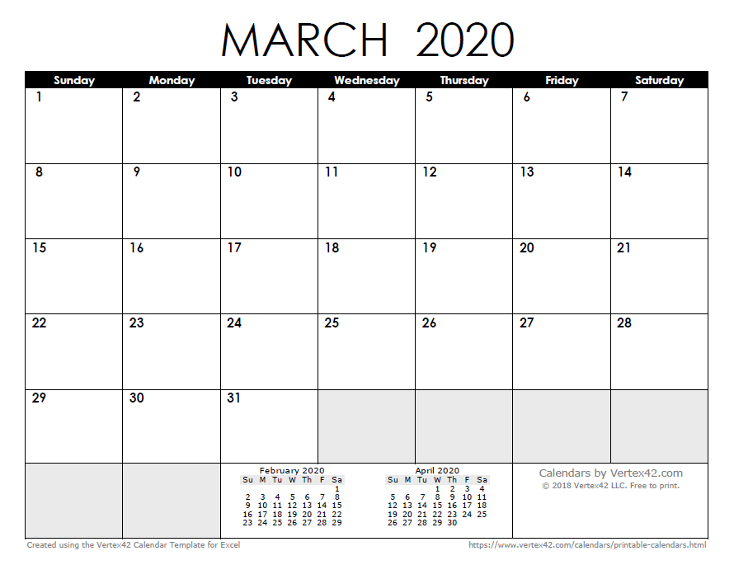
Rest
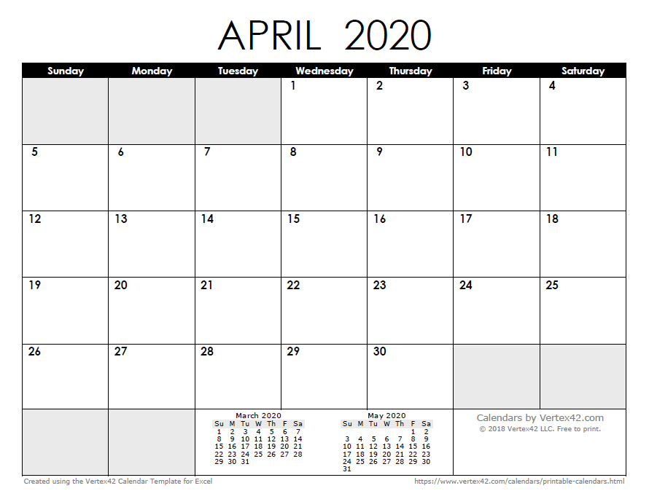
Rest
Rest
Rest
Rest
Back to School
Rest
Rest
Rest
Rest
Rest
First Day at Home
Rest
Rest
Rest
Rest
Rest
Rest
Rest
Rest

