**Functions: Understand linear functions**

1) Find equations of the lines passing through (3,-1) and having the following characteristics.

a) Slope of and put in slope-intercept form.

b) Perpendicular to the line and put into point-slope form.

c) Passing through the point (3, 2)

2) Find the exact x and y intercept of line with an equation.

3) Write a point-slope equation for a line which passes through (-2, 3) and (4, 10). Use (-2, 3) as.

4) Write a slope-intercept equation for a line which passes through (-5, 2) and (1, 5).

5) What is the zero of the linear equation?

6) **Do the problem below. Justify your answers**. 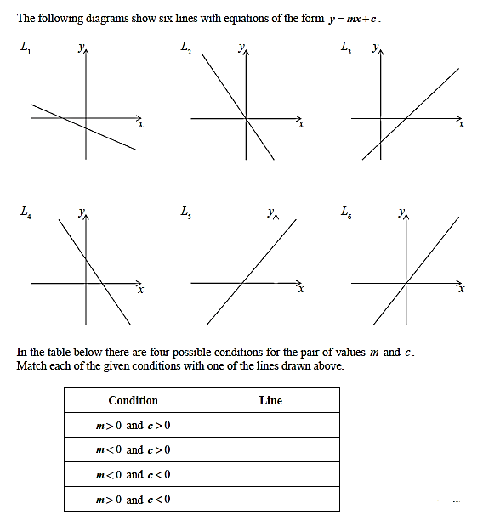

**Functions: Understanding function notation, intercepts and range and domain**

1. **Do the problem below**

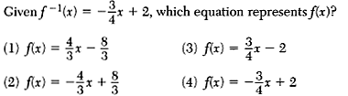

1. **Do the problem below.**

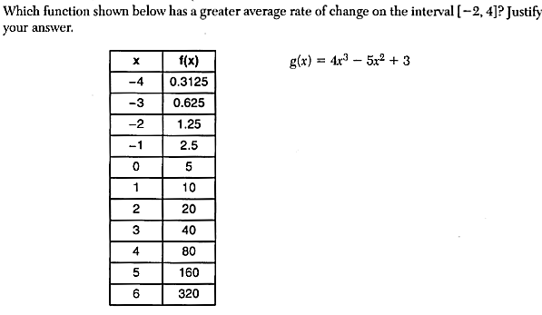

1. If , then  is equal to which of the following?

A  B  C  D 

1. Find the x-intercept, y-intercept and range for each of the following quadratic functions.

 

1. Let 

Sketch the graph of .

Evaluate: 

1. **Answer the problems below. Justify your answer**

|  |  |
| --- | --- |
| a) For the table below representing R(t), what is the average rate of change on [4,15]? | b) For the graph of f(x) below, what interval is f(x) increasing AND f(x)<0?    For what value of x does change from positive to negative? From increasing to decreasing? |
| c)For the graph of f(x) below, what intervals is positive and negative? What intervals is the slope of positive, negative, and 0? | d) For the graph of f(x) below, what are the absolute minimum and absolute maximum values of f(x)? |

Given that, , and 

7) Find .

8) Find 

9) a) Find .

b) Find .

**10) Do the problem below and justify your answer.**

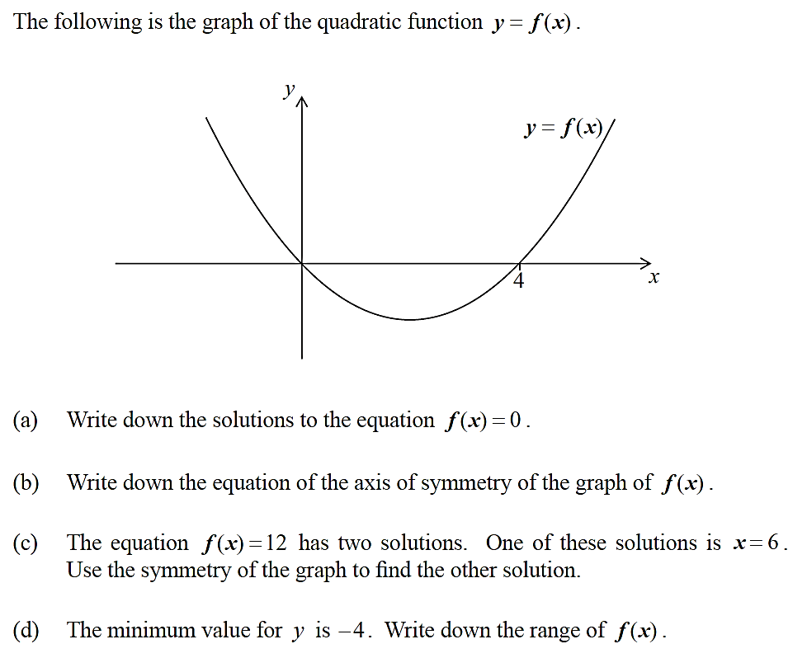

**Exponential/Logarithmic Functions**

Rewrite each equation to be in the form …

|  |  |  |  |
| --- | --- | --- | --- |
|  |  |  |  |

Solve each equation for x and show all supporting work.

|  |  |  |  |
| --- | --- | --- | --- |
|  |  |  |  |

**Rational/ Radical Functions: Operations and understanding concepts.**

1. Solve algebraically for *x*: 
2. What is the domain of the functions: ,  and 
3. What is  expressed as a single fraction?
4. Find the vertical and horizontal asymptote (if there is one) for each of the following functions:

a)  b)  c)  d)  e) 

1. **Do the problem below. Justify your answers**

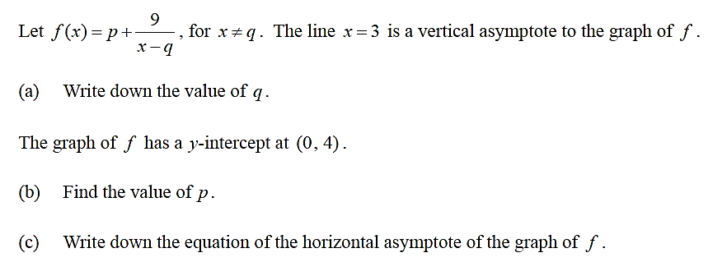

**AP Style Problem Solving**

1. The population of the city of Rud doubles every 35 years. The population of the city of Yum increases by 2.3% every year.

In the year 2000, Yum had a population of 12,000. Rud had a population of 19,000 in the year 1995.

When will the population of Yum be double that of the population of Rud? Justify your answer and give your answer in years after 2000

1. Denise stands 28 feet east and 120 feet south of Aaron. Timothy stands 80 feet east and 78 feet north of Denise.

First, Aaron walks due south until he is exactly 100 feet from Denise. Then, he turns and walks in a straight line towards Timothy.

When Aaron is closest to Denise, how far from Denise is he? Justify your answer.

1. In the year 2000, Adam invested $8000 and his investment increased at a constant rate of $120 a year for the first 5 years. In 2005, the value of Adam’s investment started to decrease and it reached $8495 in 2012. Assume that the investment decreased linearly from 2005 to 2012.
2. Write a formula for , the value of Adams’s investment t years after 2000, valid for .
3. Find all solutions to the equation .
4. You have a pizza shaped as shown below.

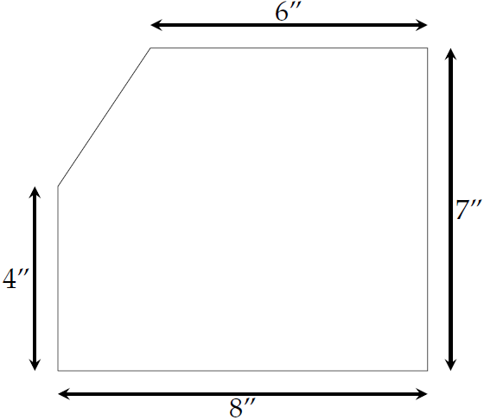

You are going to cut the pizza with a vertical cut *x* inches from the left edge. Express the area to the left of the cut as a multipart function of *x*.

1. Do the problem below. Justify your answers.

