**Quadratic Practice for Bridge to College Math**

The following task in your Bridge Packet should be completed upon return: #1,2,3,6,7,9

Then complete the following packet.

Name_______________________________________

1. **Use the graph below to identify the following key features:**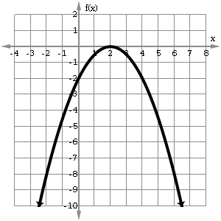

-intercept(s)___________________

-intercept_____________________

Vertex_________________________

Axis of Symmetry________________

Concavity______________________

Domain________________________

Range_________________________

Increasing______________________

Decreasing_____________________

Equation in Vertex form

___________________________________

1. **Write the following equations given the various information. Look up Factored form, Standard Form, and Vertex Form of a quadratic if necessary.**
2. Factored form; Roots are -3 and 10, a = -1/2
3. Standard form; a = -4, b = 1, c = 0
4. Vertex form; a = -1 ; vertex is (-2, 5)

**Application Problem: Quadratic Functions in Standard Form**

*“Desmos” is a good graphing site if you need to graph the functions. It is free and has an app for phones as well. Feel free to use that to help you answer these.*

1. Jose throws a ball to form the quadratic . The function measures the path of the ball in feet per second. Use this information to find the following.
2. **What is the starting height of the ball? ________ (y-intercept)**
3. **When did the ball reach its maximum height? ________(axis of Symmetry)**
4. **What was the ball’s maximum height?___________(y-value of vertex)**
5. Red bird follows the path of the following quadratic function measured in feet per second. Use this function to answer the following questions and graph the bird’s path.
6. **What is the starting height of the ball? ________**
7. **When did the ball reach its maximum height? ________**
8. **What was the ball’s maximum height?___________**

